Azure AD setup for Paycor Scheduling

!

1. In Azure AD, navigate to Enterprise Applications, click on “+ New Application”, and then “+ Create your own application”. Name it and select “Integrate any other application you don't findin the gallery (Non-gallery)”, and click Create.
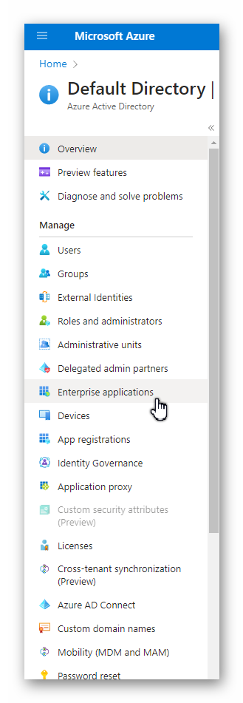
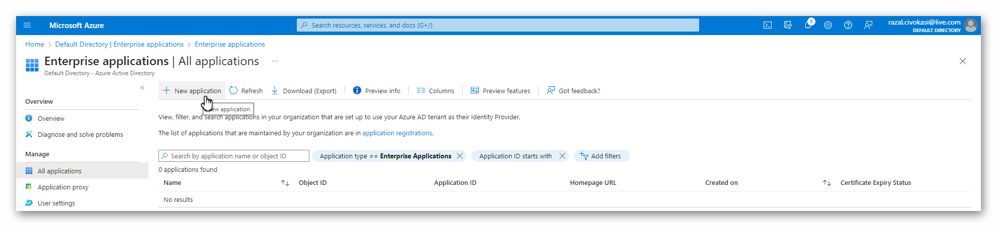
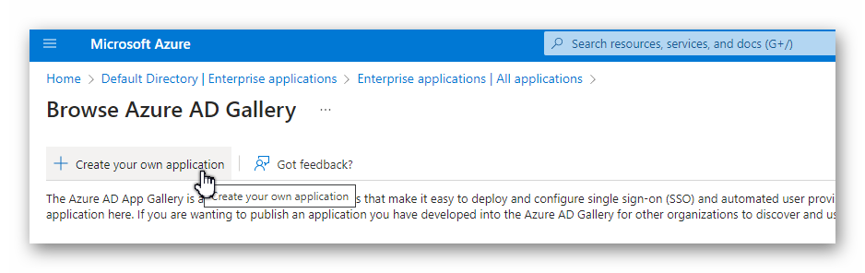
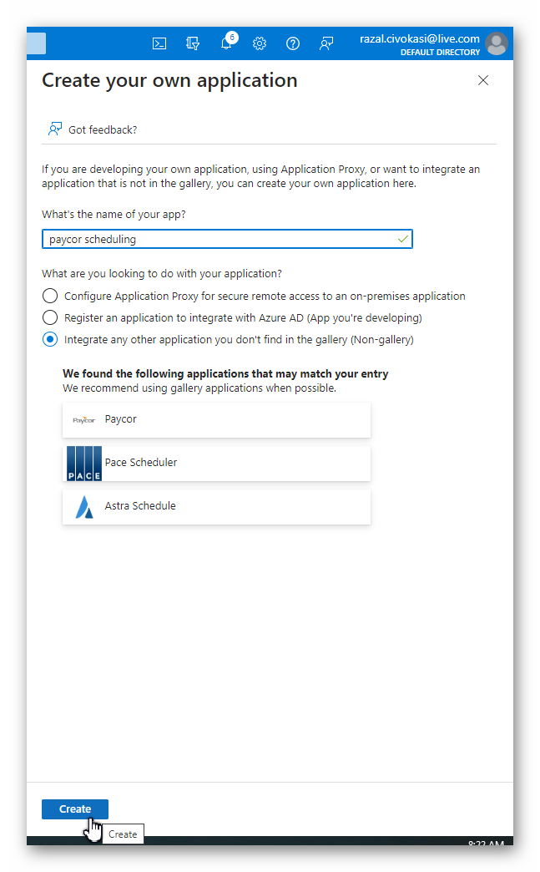
2. Click on “Get Started” under “2. Set up single sign on” and select “SAML”.
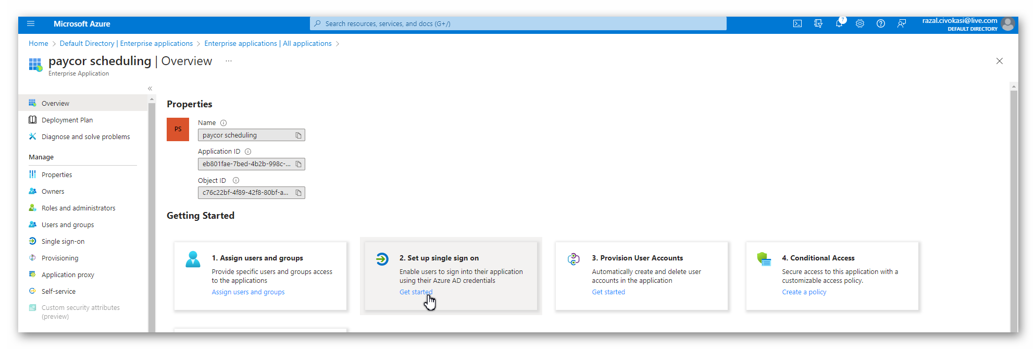
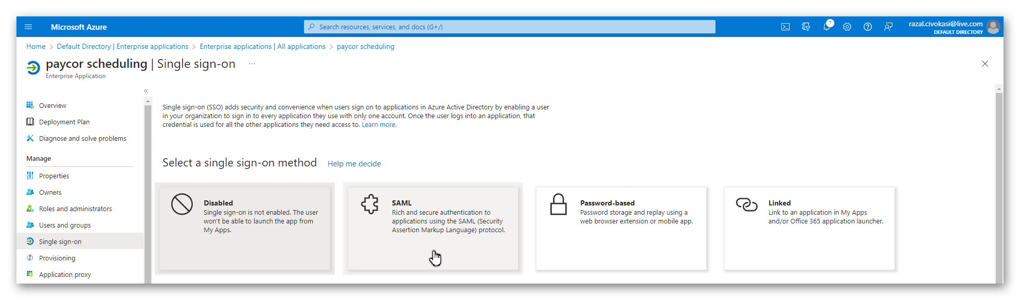
3. Paste the “Azure AD Identifier” url into the Paycor Scheduling “App Url” field, and the “App Federation Metadata URL” into the Paycor Scheduling “AppMetaDataUrl” field.
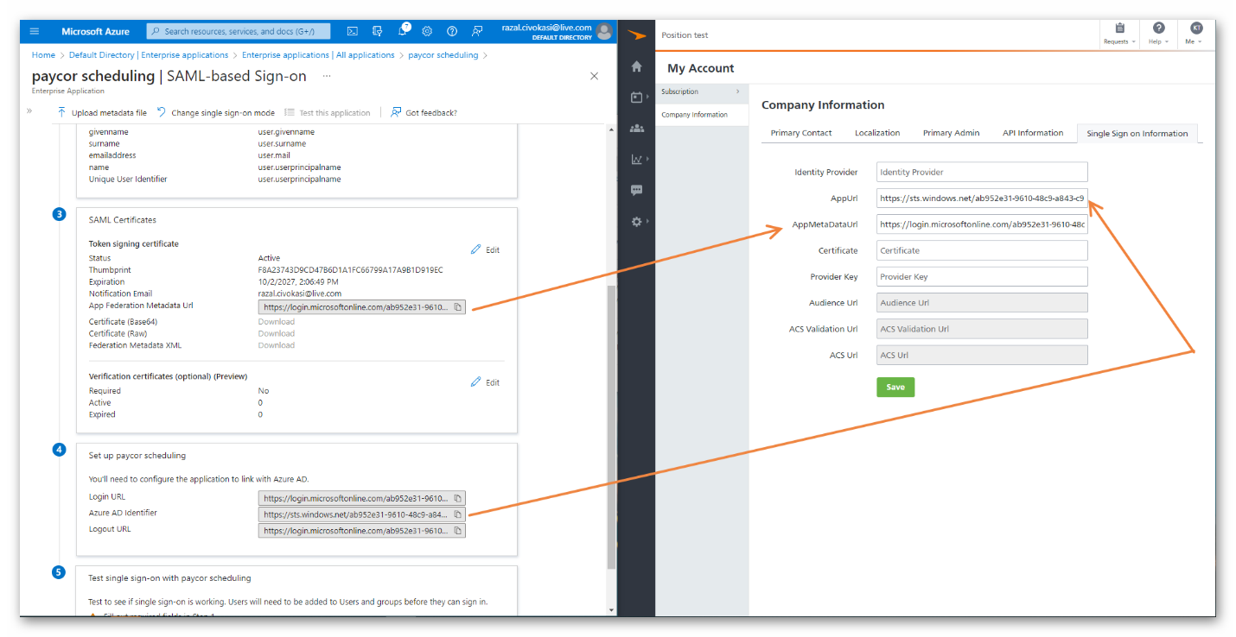
4. Open the App Federation Metadata URL in a new tab, find the first “<X509Certificate>” line and copy everything in between “<X509Certificate>” and “</X509Certificate>” into the Paycor Scheduling “Certificate” field.

5. Add a Provider Key to your liking. I suggest something simple, the name or abbreviation of your company name, and then press “Save”. This will then generate the 3 Url fields in the bottom in Paycor Scheduling.
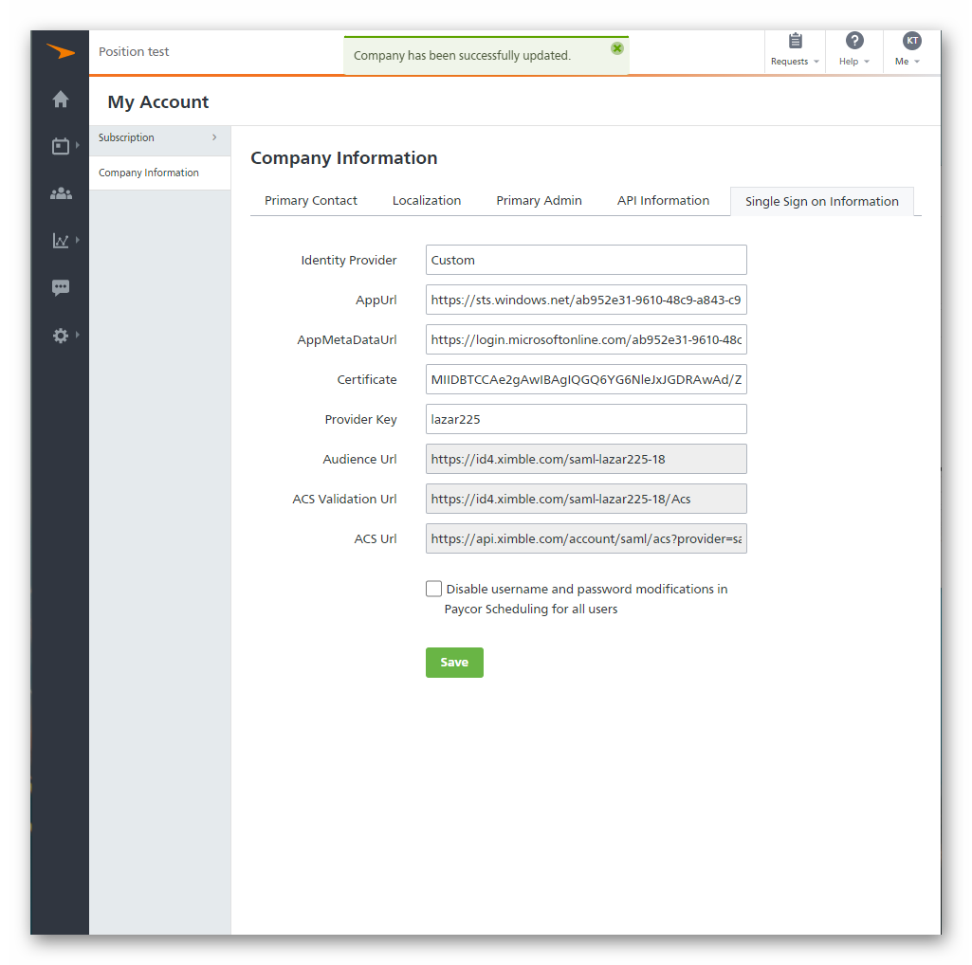

6. Next, please click on “Edit” in line with “Basic SAML Configuration” in Azure, and then paste the “Audience URL” into the “Identifier (Entity ID)”, the “ACS Validation URL” into the “Reply URL (Assertion Consumer Service URL)”, and the “ACS Url” into “Sign on URL (Optional)”, and press Save in the top in Azure.
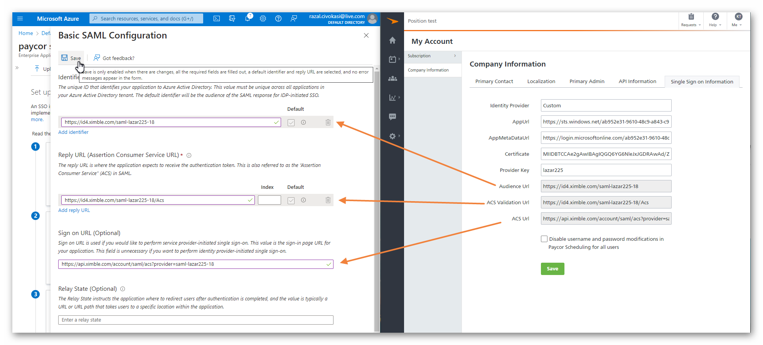

7. After all of the above is complete, please assign your users and groups onto the new application. If you assigned yourself already, you may go ahead and test the connection.
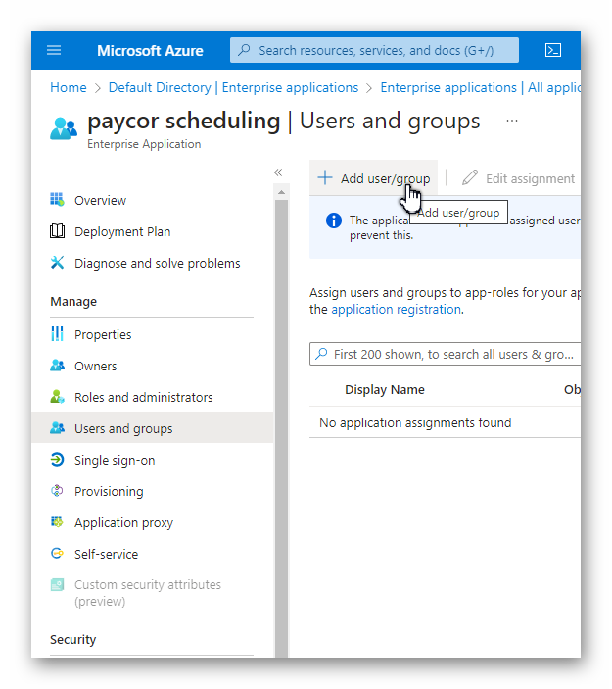
The test will not always work, so please give it a couple of minutes, refresh the page in Azure and test again.
If the tests continue to fail, the certificate xml should be downloaded and opened this time, and step 4 should be repeated using said file. After that, step 6 must be done again as well.
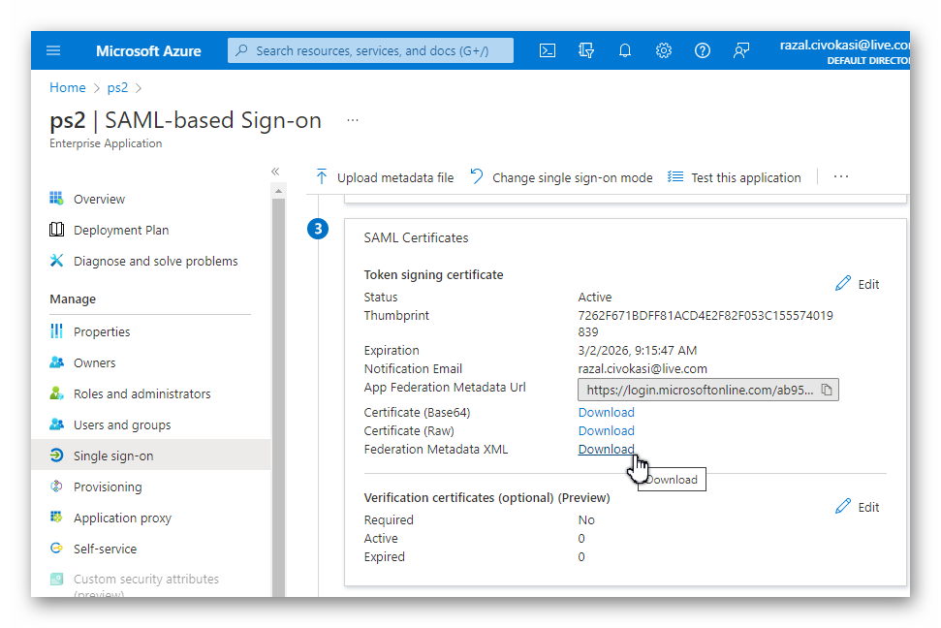
The test will not always work, so please give it a couple of minutes, refresh the page in Azure and test again.
This will only work if the username and email fields in Paycor Scheduling are the same.

