How to configure SAML Okta SSO
- In Okta, navigate to Applications.
- Select Create New App.
- On the new menu that opens, select SAML 2.0 as the Sign on method.
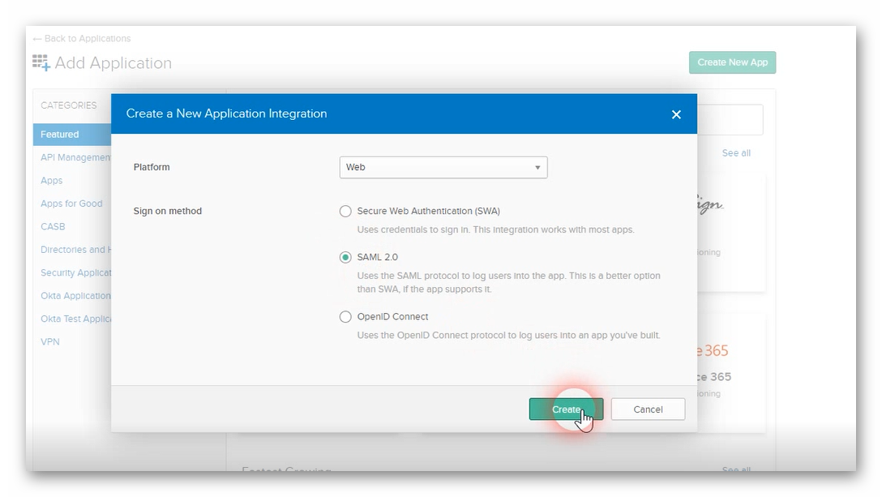

- General Settings window will open. Input the app name – for example – Paycor Scheduling. Select Next.
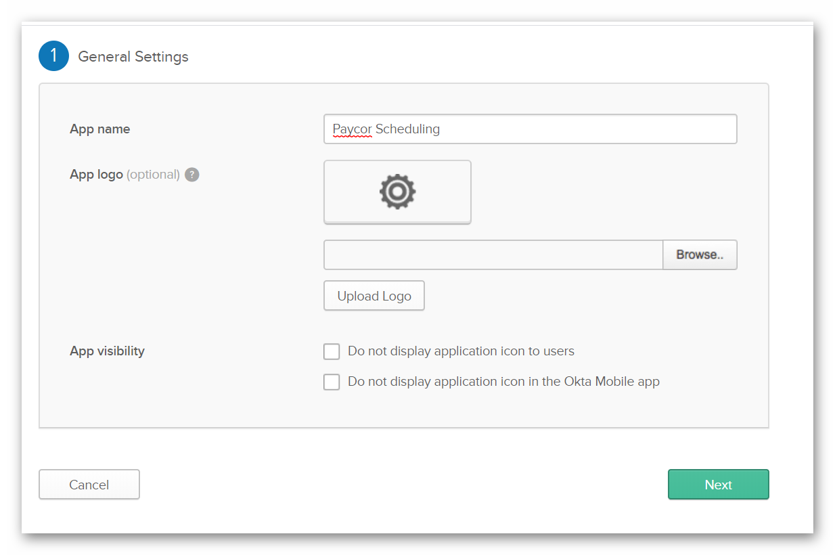

- SAML Settings will open. Input any valid link starting with https:// into Single Sign On / Audience URL (SP Entity ID) fields. This will be changed later.
- Select “Allow this app to request other SSO URL’s”.

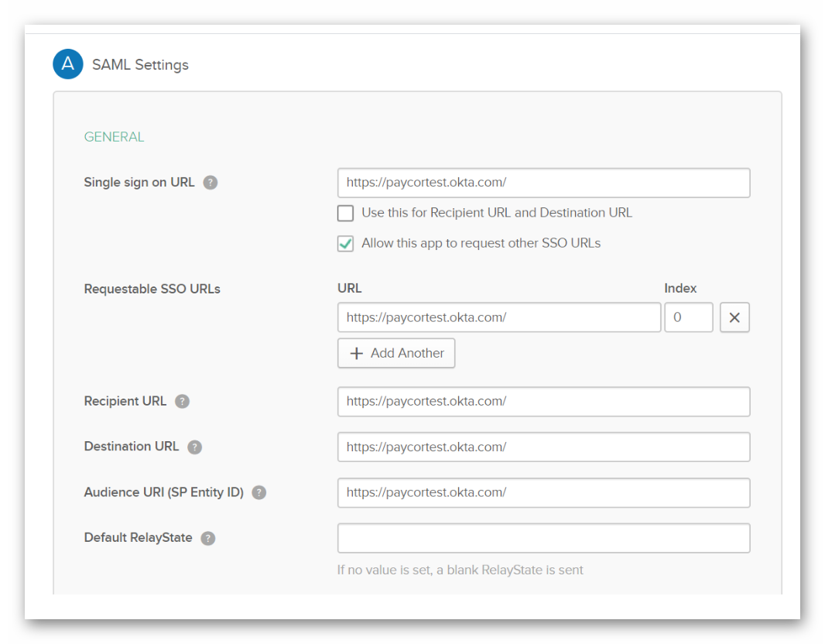
- Select Next. On the next window select either I’m an Okta customer adding an internal app / I’m a software vendor I’d like to integrate my app with Okta. Select Finish.
- You have now created a generic SAML App in Okta. Settings in Okta are located under Sign On.

- In the next steps, you’ll need to populate the fields in Paycor Scheduling with the information from Okta.
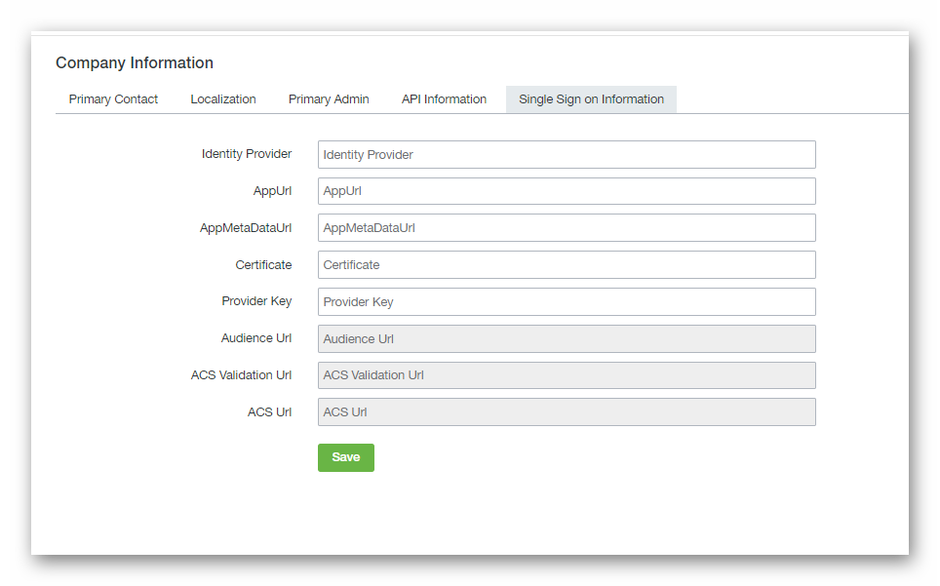
- AppMetaDataUrl – Copy the link address of Identity Provider metadata to Paycor Scheduling. The link is located in Okta under Sign On > Settings.
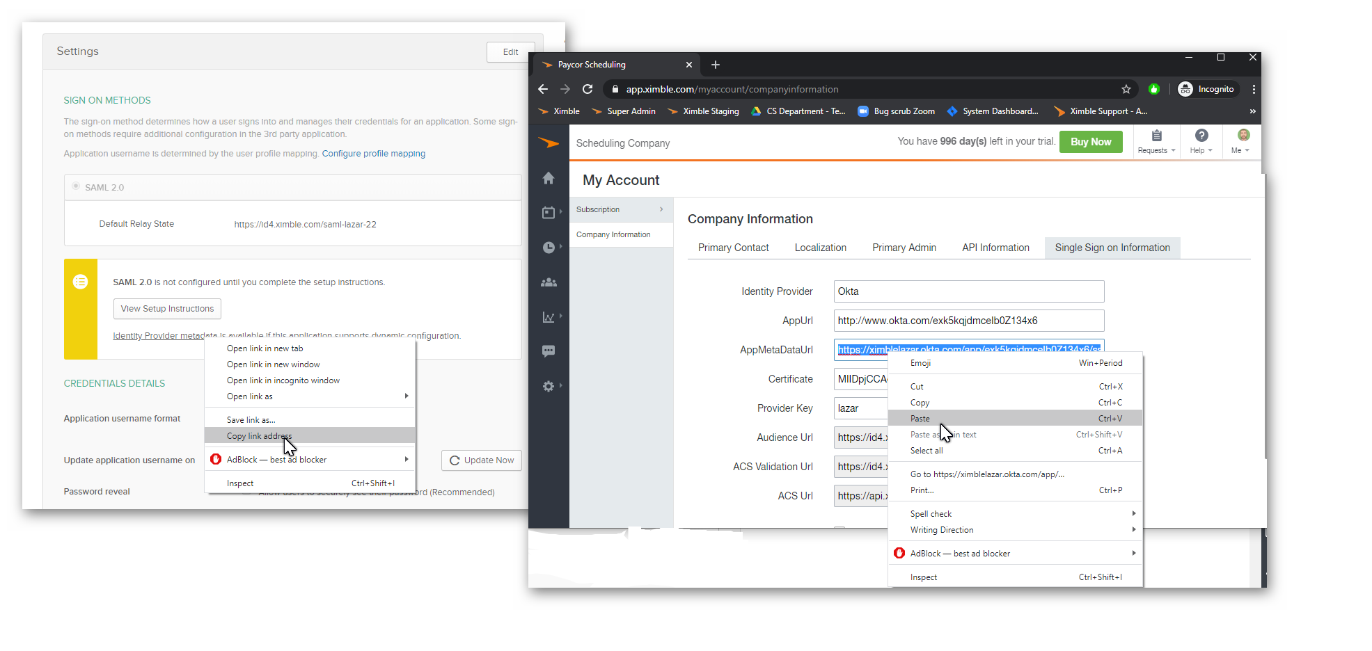

- Open View Setup Instructions in Okta (Sign On > Settings).
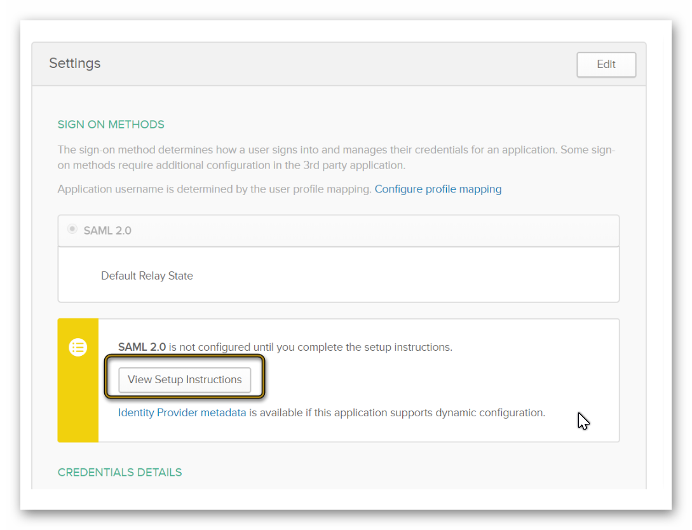
- From the Setup instructions page, copy Identity Provider Issuer into App URL in Paycor Scheduling.
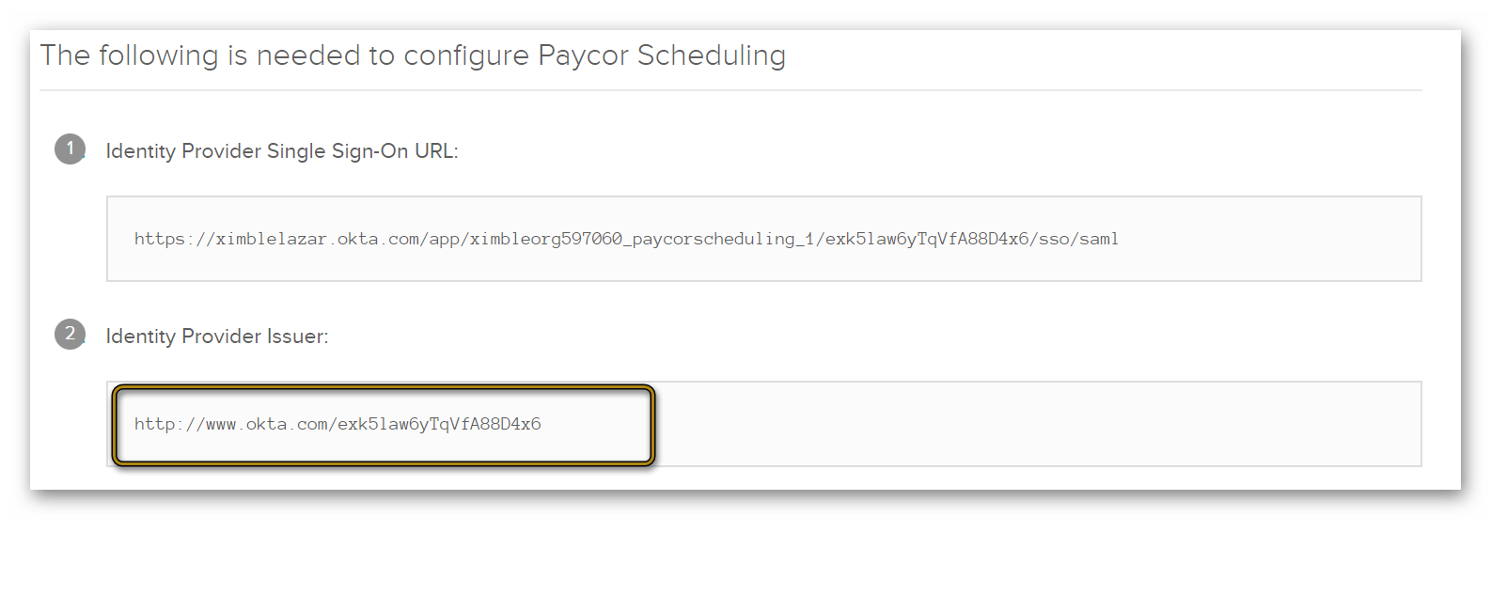

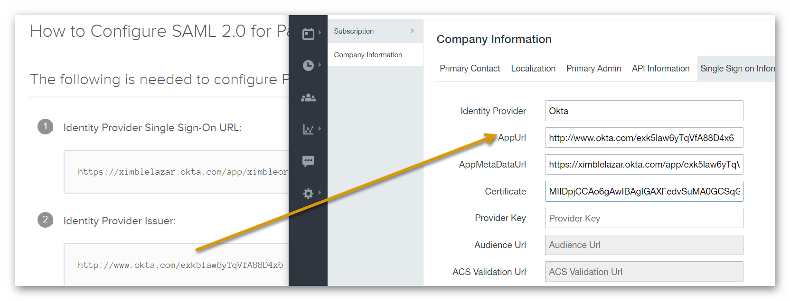

- Identity Provider - this is only the name of the configuration. Insert – Okta

- Certificate – copy the data from the metadata file. This is located in Okta under Sign On > Settings > View Setup Instructions. (Copy the link of AppMetaDataUrl into your browser and copy the certificate from there / or copy the certificate from the Setup Instructions page).
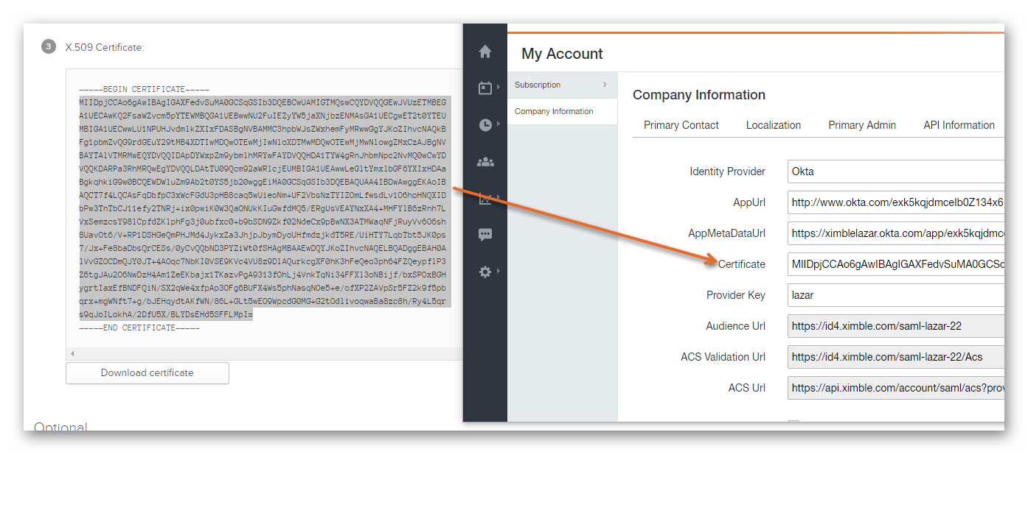

- Provider Key – enter anything you want or leave the field blank, it will auto-populate.
- After you have populated the fields above, select “Save”.
- Audience URL, ACR Validation URL and ACS URL will generate automatically.
- In Okta, navigate to General. Under SAML Settings select Edit. Select Next which will take you to the configuration of the SAML Settings.
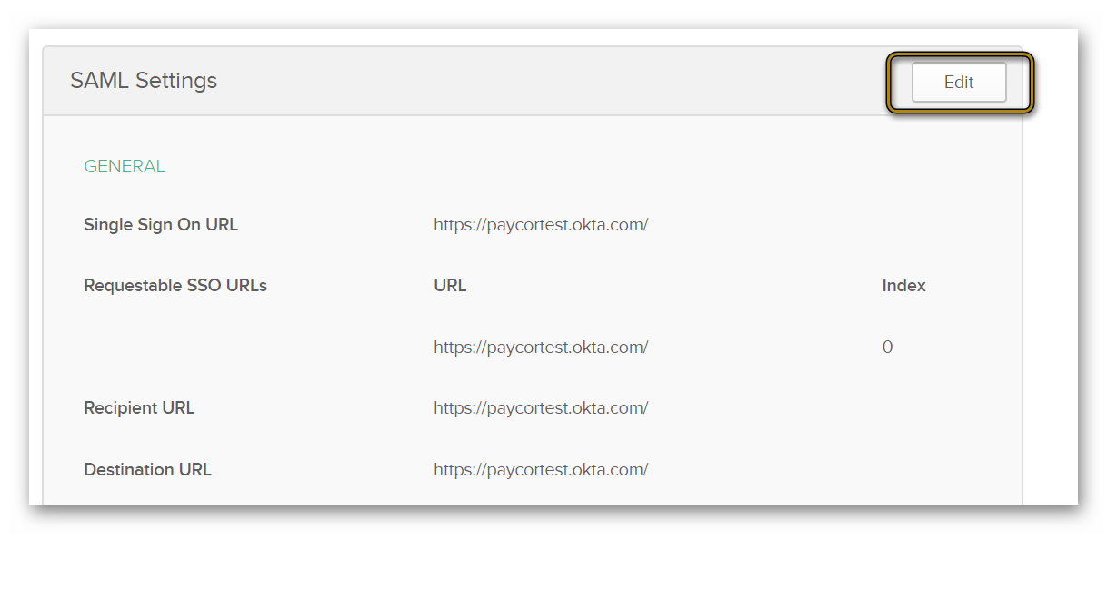
- Copy ACS URL from Paycor Scheduling into Single Sign On URL in Okta.

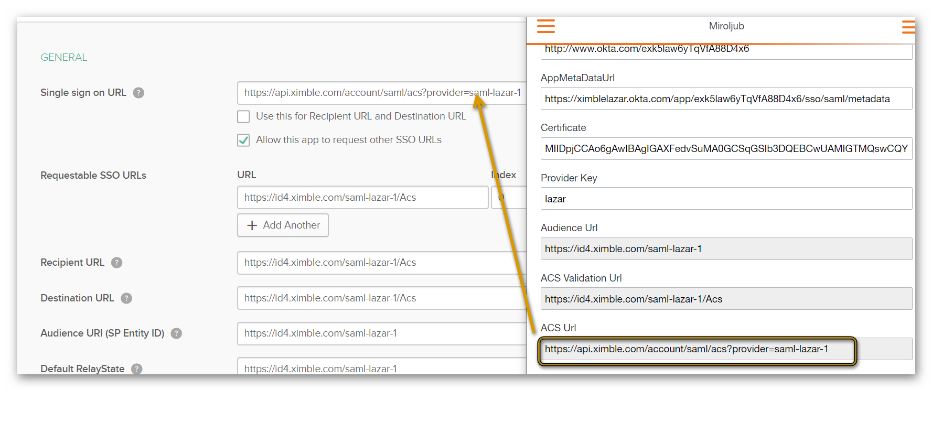
- Copy Audience URL from Paycor Scheduling into Audience URL (SP Entity ID) and Default Relay State in Okta.

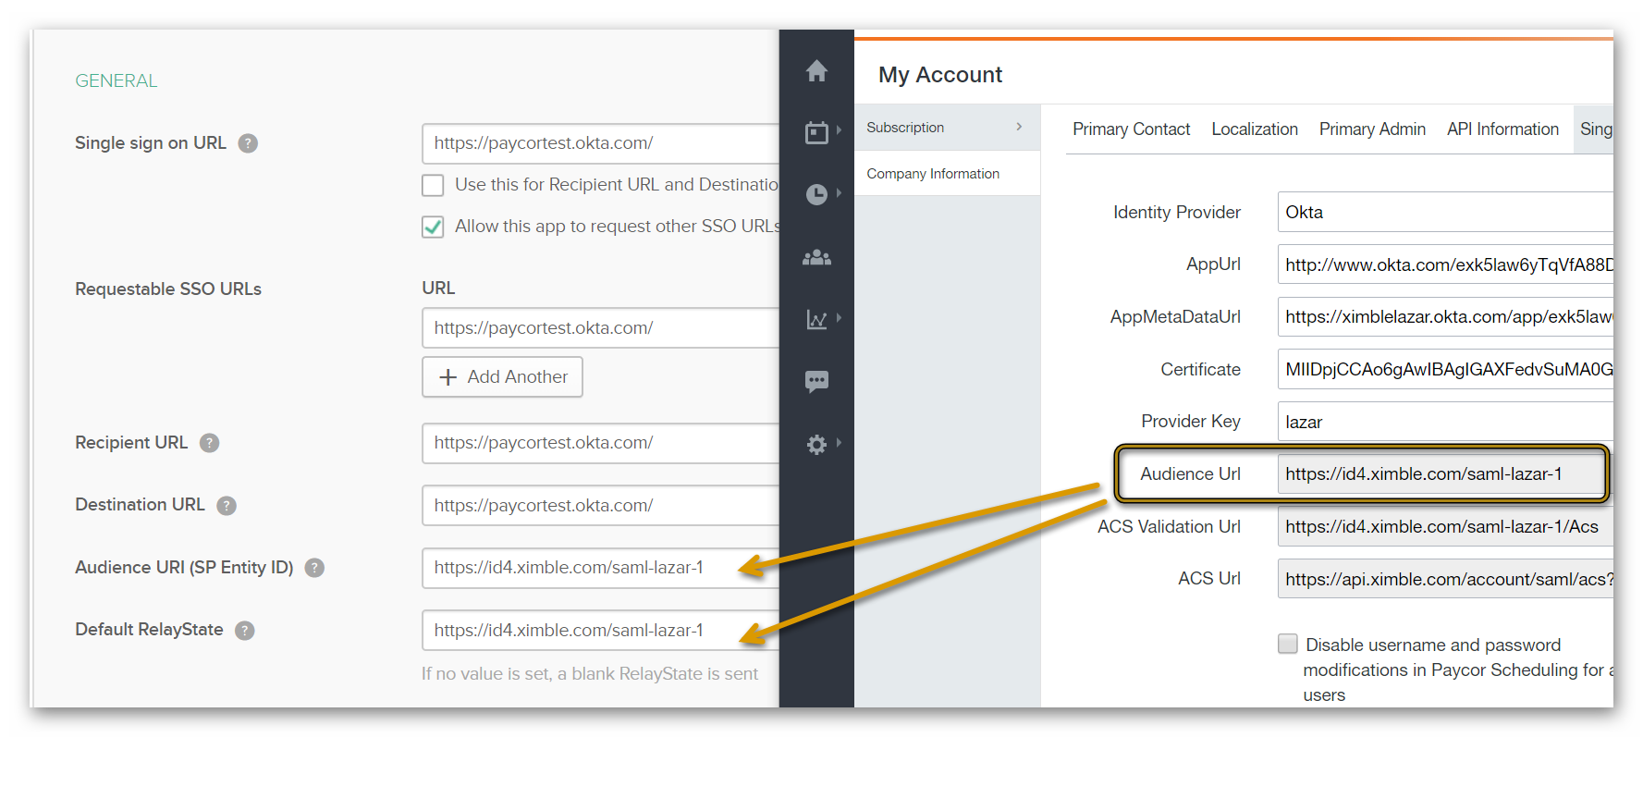
- Select “Allow this app to request other SSO URL’s” in Okta.

- Copy ACS Validation URL from Paycor Scheduling into Requestable SSO URLs, Destination URL and Recipient URL in Okta.
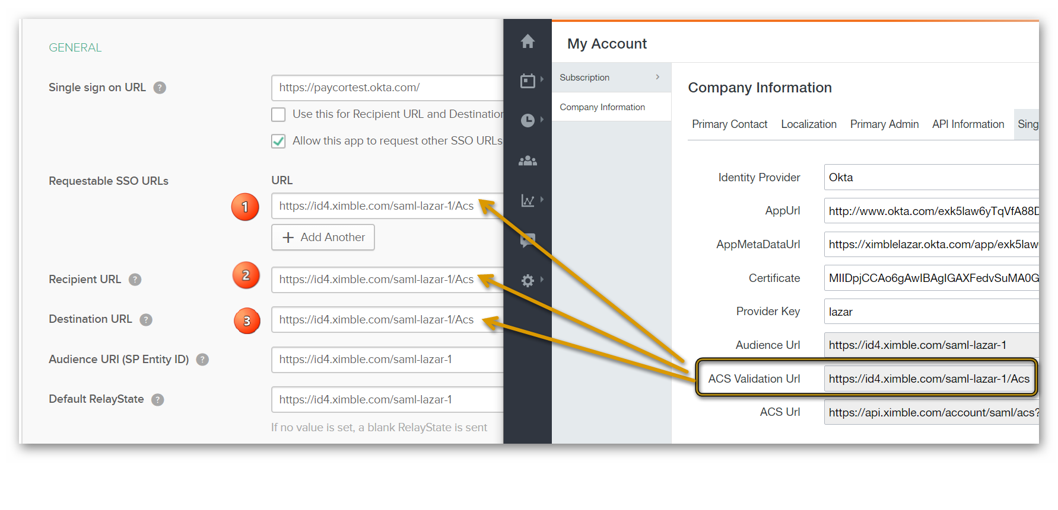

- Save the configuration in Okta.

- Navigate to Assignments. Select Assign > Assign to People.
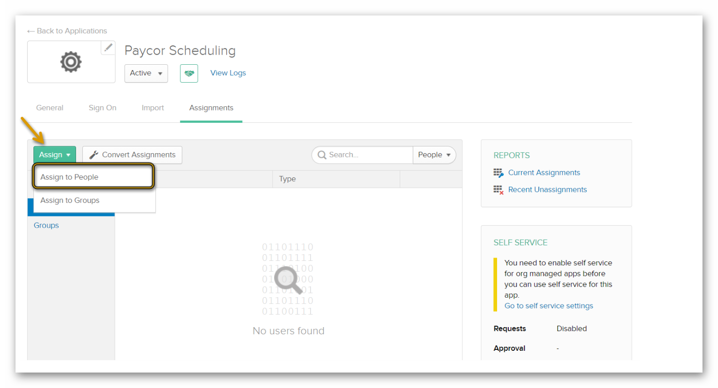
- Assign the SSO configuration to the users who will be using the SSO for Paycor Scheduling. Select Done.
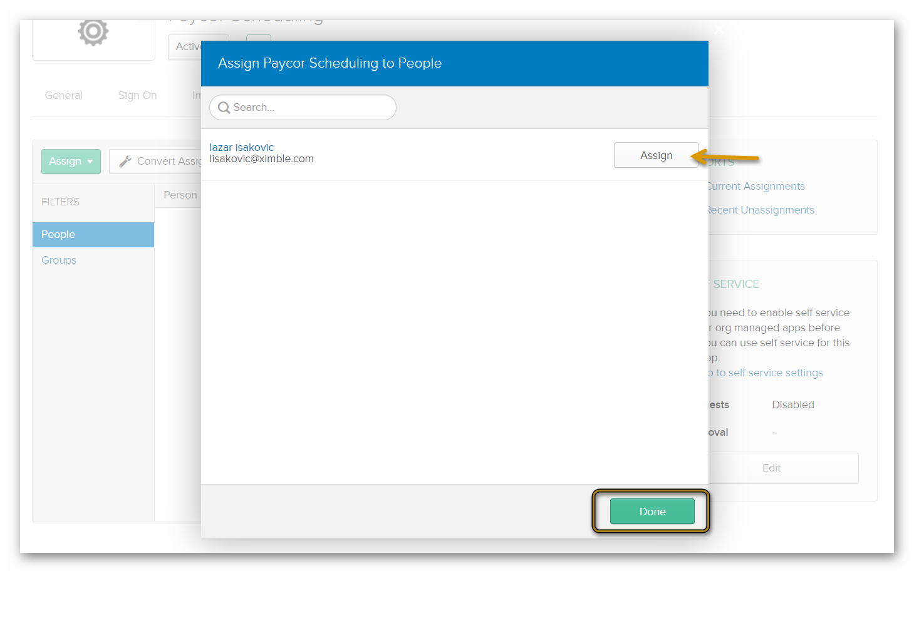
- Navigate to My Apps in Okta. Click on the created app and use the SSO.

