1. In the Idaptive admin panel, please navigate to 'Web Apps>Add Web Apps'. Choose 'Custom', and then press 'Add' next to 'SAML', and confirm your selection. Close the small window.
2. The edit screen will appear for the new app. Please name it as you wish, and then navigate to 'Trust' on the side.
3. Under 'Identity Provider Configuration' , please choose 'Metadata', and copy the link from under 'IdP Entity ID / Issuer' to the 'AppUrl' field in Paycor Scheduling.
4. Copy the URL field from under 'Single Sign on URL' to the 'AppMetaDataUrl' field in Paycor Scheduling.
​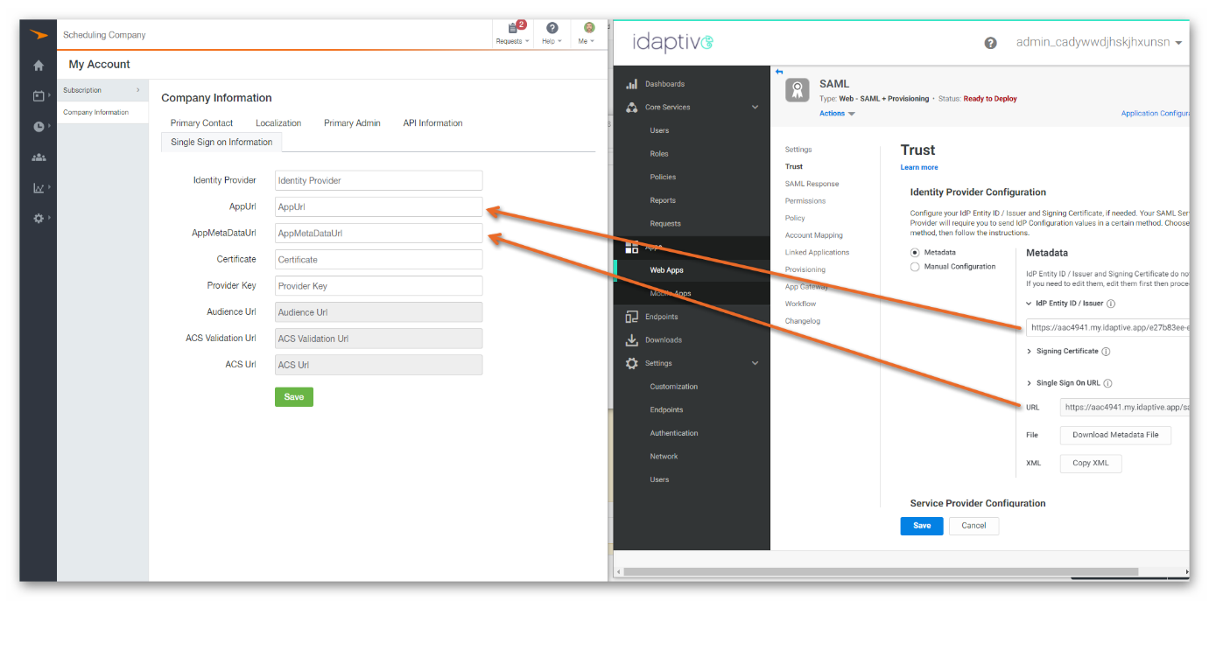​
5. Open your Metadata file, and copy the certificate into the 'Certificate' field in Paycor Scheduling.
​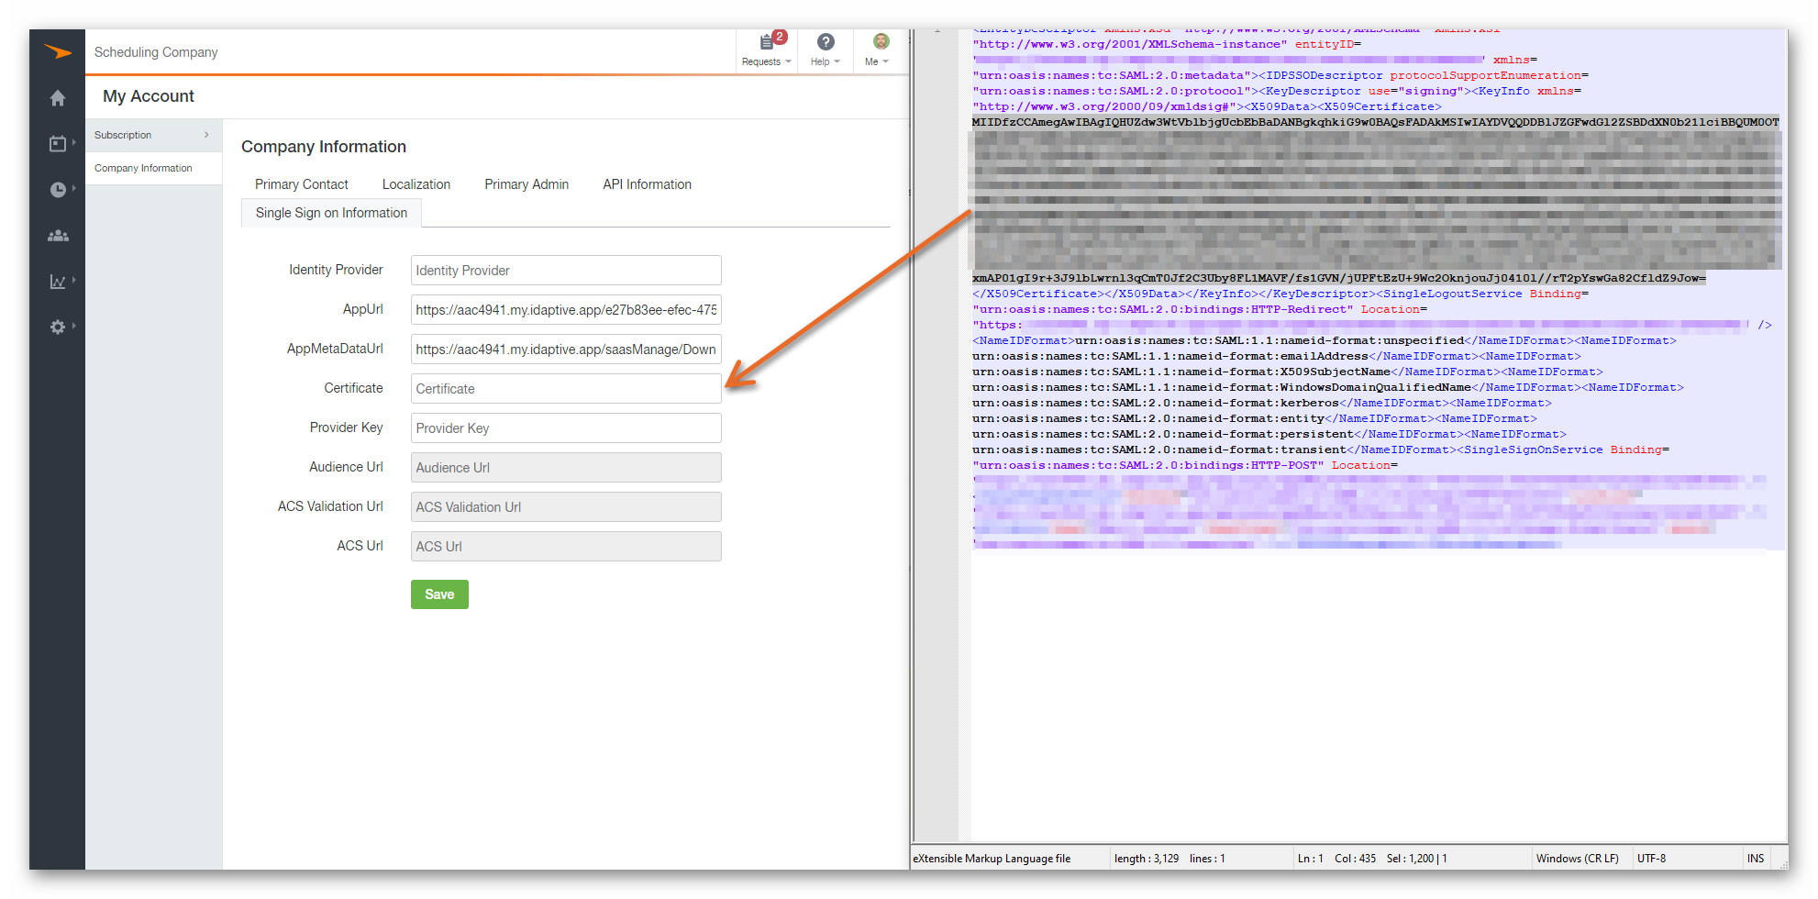​
6. Press Save in Paycor Scheduling. This will generate the three bottom links/URLs.
7. In Idaptive, please scroll down to 'Service Provider Configuration', and select 'Manual Configuration'.
8. From Paycor Scheduling, please copy the 'Audience Url' in to the 'SP Entity ID / Issuer / Audience' field in Idaptive.
9. From Paycor Scheduling, please copy the 'Acs Validation Url' in to the 'Assertion Consumer Service (ACS) URL' field in Idaptive.
​​​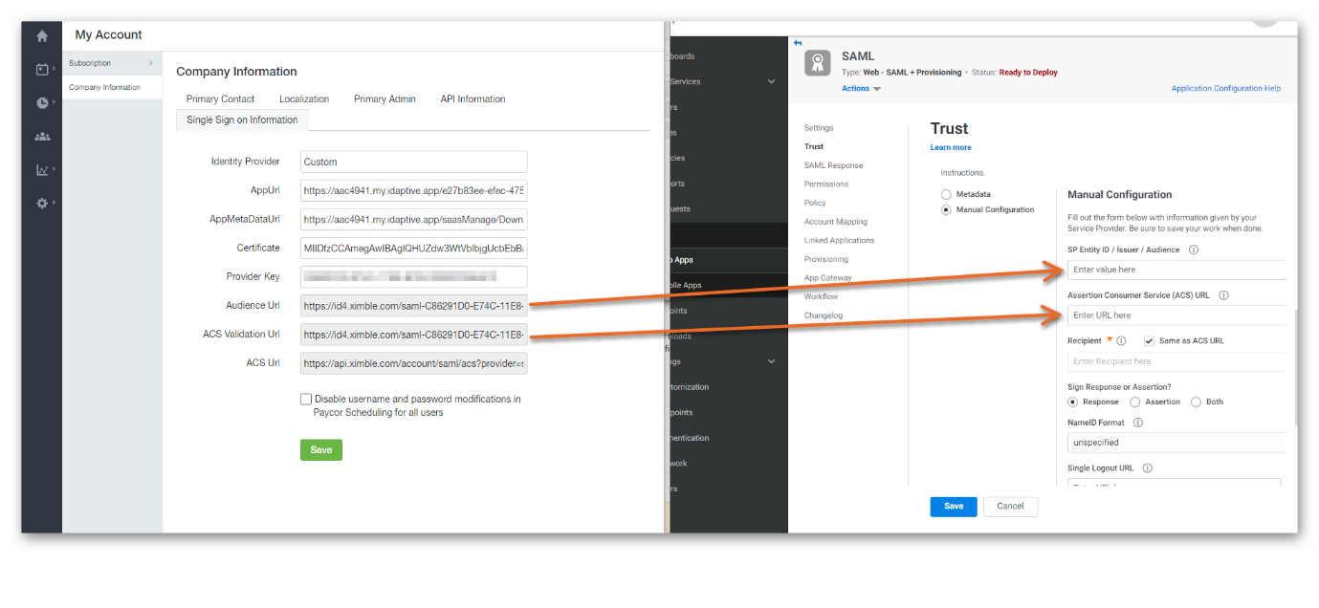​
10. Please navigate to 'Saml Response' in Idaptive. Press 'Add', and define 'email' as the new Attribute name, and select 'LoginUser.Email' as the Attribute value.
11. In Idaptive, under Permissions, please add any users you wish to use the SSO for Paycor Scheduling.
12. Save.
Please note that this will work only if the users email in Paycor Scheduling corresponds to the users email in Idaptive.
Each time 'Save' is pressed in the Paycor Scheduling Single Sign On Information screen, the Audience, ACS Validation, and ACS URLs will be changed slightly. This means that each time 'Save' is pressed in the Paycor Scheduling Single Sign On Information screen, steps 8. and 9. must be repeated.

